# Augmented Reality Assignment3

Mohit Kumar Pandey – mkp114

**Part 1**

Matrix P size 16x12

2 2 2 1 0 0 0 0 844 844 844 422

0 0 0 0 2 2 2 1 646 646 646 323

-2 2 2 1 0 0 0 0 -356 356 356 178

0 0 0 0 -2 2 2 1 -646 646 646 323

-2 2 -2 1 0 0 0 0 -236 236 -236 118

0 0 0 0 -2 2 -2 1 -966 966 -966 483

2 2 -2 1 0 0 0 0 964 964 -964 482

0 0 0 0 2 2 -2 1 966 966 -966 483

2 -2 2 1 0 0 0 0 876 -876 876 438

0 0 0 0 2 -2 2 1 146 -146 146 73

-2 -2 2 1 0 0 0 0 -324 -324 324 162

0 0 0 0 -2 -2 2 1 -146 -146 146 73

-2 -2 -2 1 0 0 0 0 -156 -156 -156 78

0 0 0 0 -2 -2 -2 1 -234 -234 -234 117

2 -2 -2 1 0 0 0 0 1044 -1044 -1044 522

0 0 0 0 2 -2 -2 1 234 -234 -234 117

Projection Matrix M

-0.1925 -0.0283 -0.0786 -0.7346

-0.0000 -0.2044 -0.0001 -0.6120

0.0000 0.0001 0.0003 0.0024

Euclidean coordinates of camera center (x y z)

-4.41164113296547e-06 -2.99121429585660 -8.26953908183251

Matrix M'

-734.6289 -107.8955 -299.9999

-0.0009 -780.1442 -0.2641

0.0000 0.3597 1.0000

theta_x_deg =

19.7812

R_x =

1.0000 0 0

0 0.9410 0.3384

0 -0.3384 0.9410

N =

-734.6289 0.0000 -318.8125

-0.0009 -734.0199 -264.2723

0.0000 0 1.0627

**Part II**

Homography for images2.png

1.7313 0.1558 67.0000

0.0450 -1.5808 410.0000

0.0000 0.0004 1.0000

Homography for images9.png

2.2127 0.0583 134.0000

0.2986 -1.9093 422.0000

0.0011 0.0002 1.0000

Homography for images12.png

1.1118 0.0815 104.0000

-0.2843 -1.4063 392.0000

-0.0009 0.0003 1.0000

Homography for images20.png

1.6437 0.5348 128.0000

-0.0290 -0.7725 275.0000

-0.0001 0.0016 1.0000

Intrinsic Params

v0 =

229.3470

lambda =

-0.7657

alpha =

719.6904

beta =

703.7988

gamma =

4.8709

u0 =

323.2434

Rotation matrix for image2

0.9997 0.0222 0.0084

0.0253 -0.9894 -0.1660

0.0042 0.1661 -0.9897

Translation vector for image2

-148.9854

106.8856

416.4115

New Rotation matrix for image2 after enforcing constraints

0.0558 -0.9703 -0.2354

0.4124 0.2371 -0.8796

0.9093 -0.0480 0.4134

New Rotation matrix * Rotation Matrix_transpose for image2 after enforcing constraints

1.0000 0.0000 -0.0000

0.0000 1.0000 0.0000

-0.0000 0.0000 1.0000

Rotation matrix for image9

0.9259 -0.0041 0.3774

0.0284 -0.9953 -0.0833

0.3766 0.0883 -0.9214

Translation vector for image9

-94.3366

97.5177

356.2510

New Rotation matrix for image9 after enforcing constraints

0.8976 0.4381 0.0487

-0.4289 0.8935 -0.1331

-0.1019 0.0986 0.9899

New Rotation matrix * Rotation Matrix_transpose for image9 after enforcing constraints

1.0000 -0.0000 0.0000

-0.0000 1.0000 -0.0000

0.0000 -0.0000 1.0000

Rotation matrix for image12

0.9116 -0.0028 -0.4101

-0.0579 -0.9878 -0.1265

-0.4069 0.1400 -0.9007

Translation vector for image12

-144.3800

108.9722

471.5221

New Rotation matrix for image12 after enforcing constraints

0.9337 -0.3545 0.0503

0.3555 0.9346 -0.0131

-0.0423 0.0301 0.9986

New Rotation matrix * Rotation Matrix_transpose for image12 after enforcing constraints

1.0000 0.0000 -0.0000

0.0000 1.0000 -0.0000

-0.0000 -0.0000 1.0000

Rotation matrix for image20

0.9997 0.0094 -0.0234

-0.0105 -0.7058 -0.7066

-0.0227 0.7066 -0.7054

Translation vector for image20

-117.7165

28.1012

433.2158

New Rotation matrix for image20 after enforcing constraints

0.9331 0.2420 0.2659

-0.3585 0.6815 0.6379

-0.0269 -0.6906 0.7227

New Rotation matrix * Rotation Matrix_transpose for image20 after enforcing constraints

1.0000 0.0000 -0.0000

0.0000 1.0000 0

-0.0000 0 1.0000

**Improving Accuracy**

Projected grid corners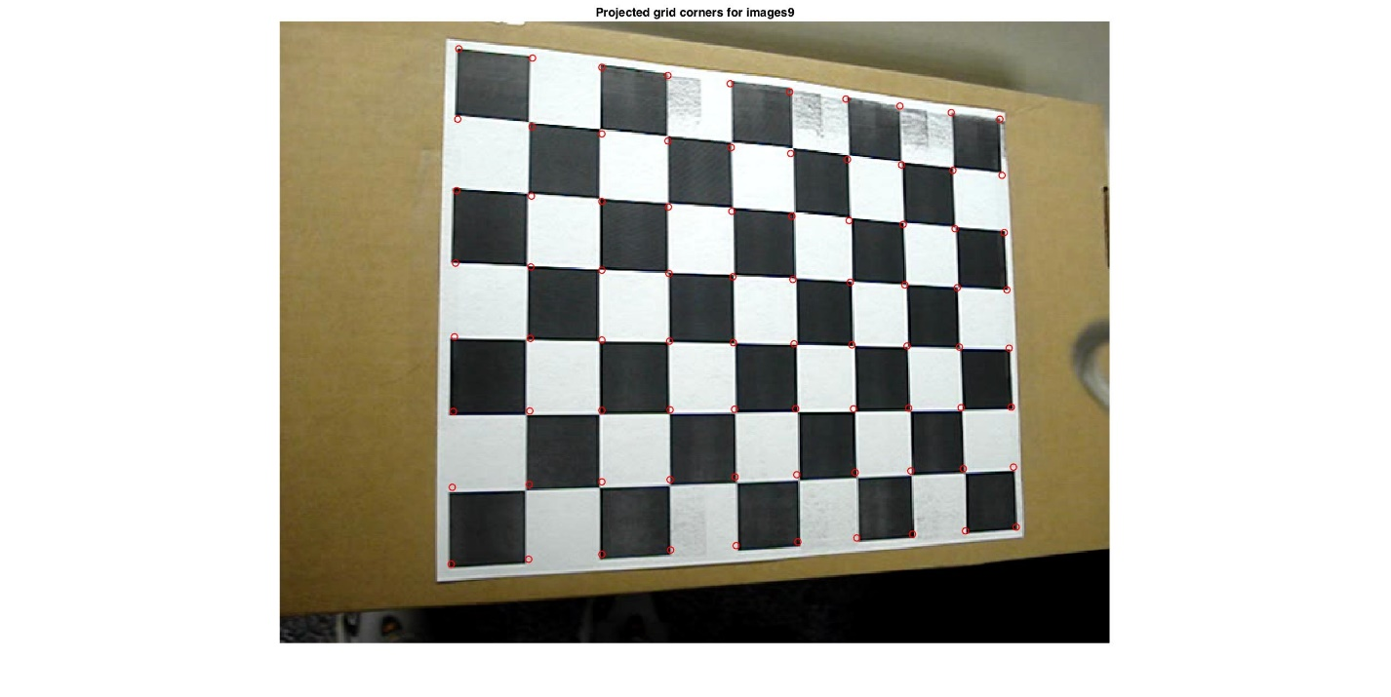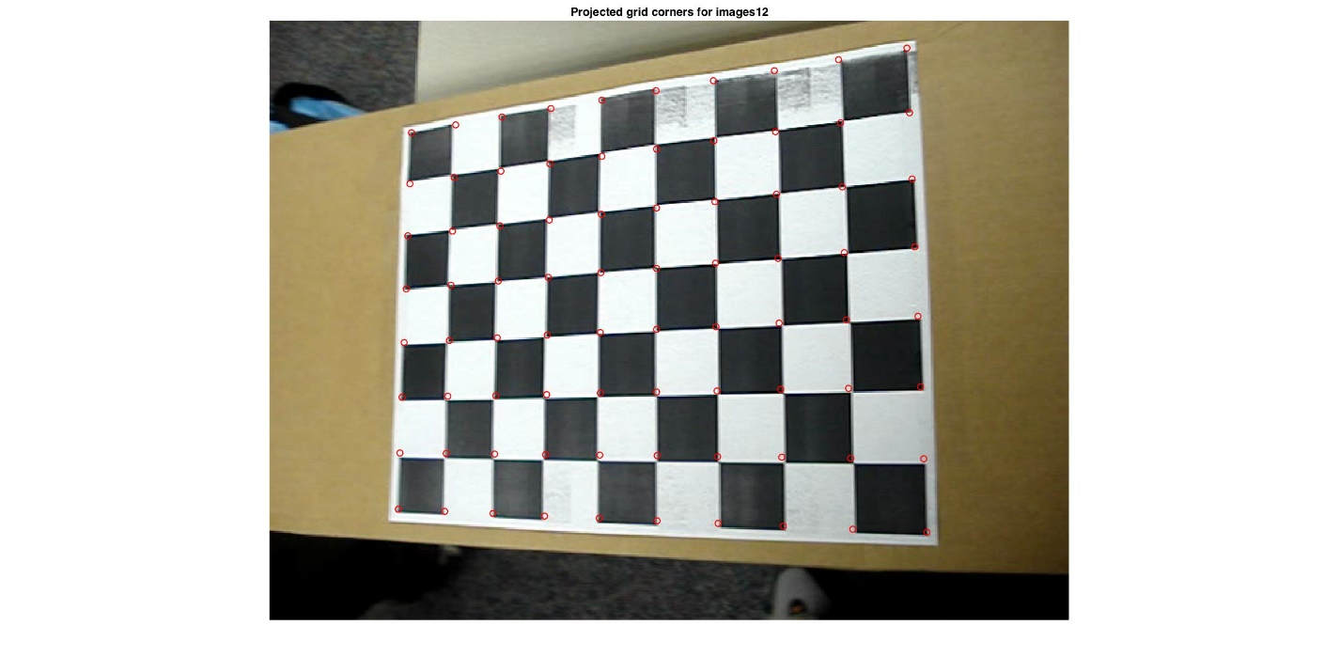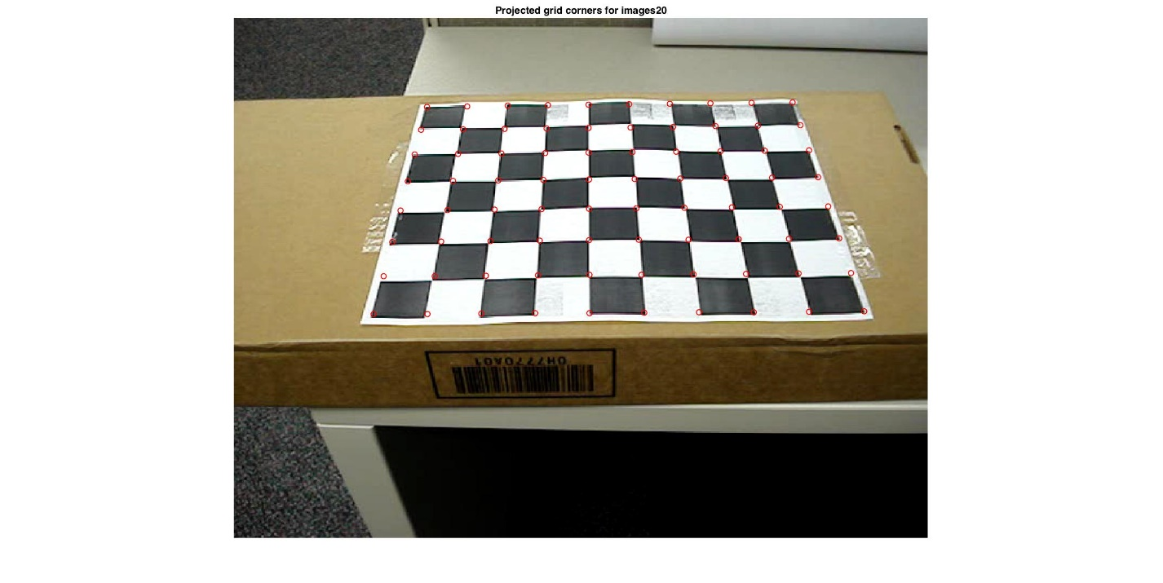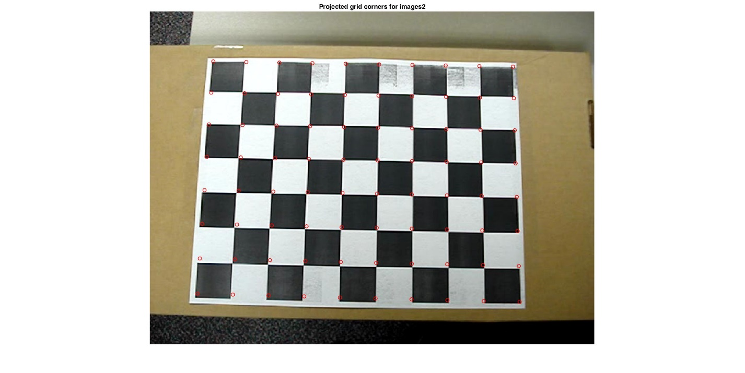

Figure 2. Harris Corners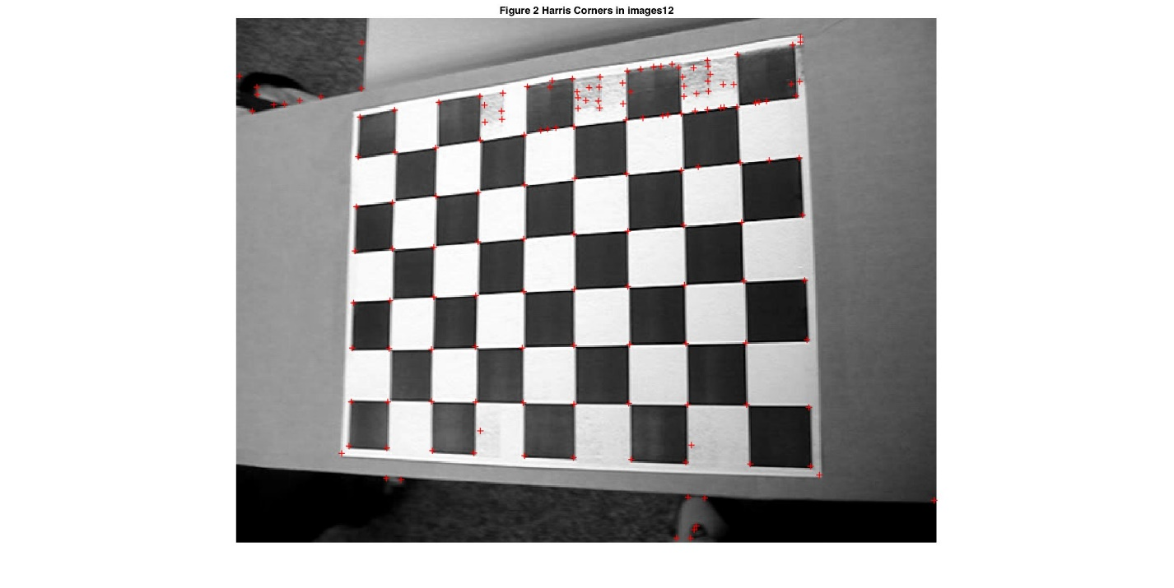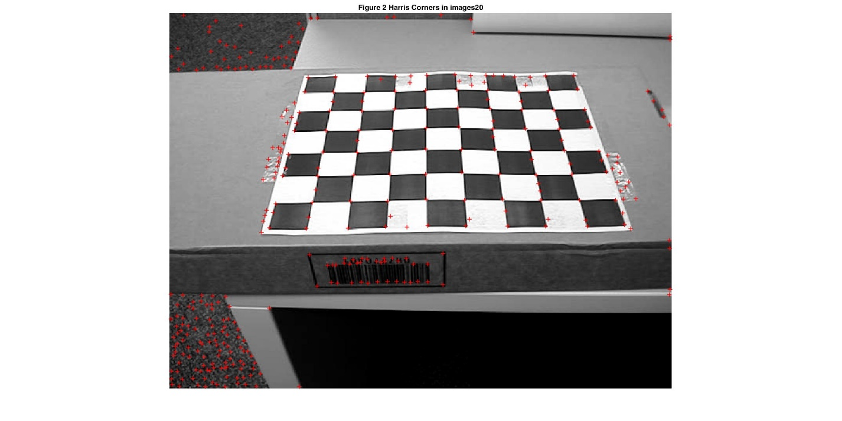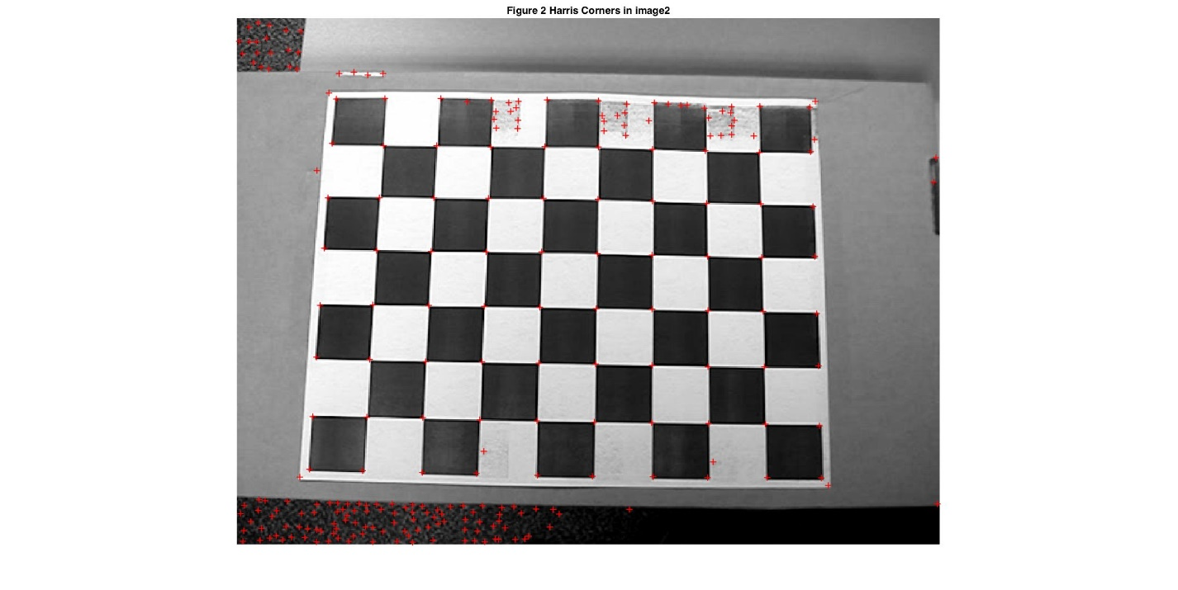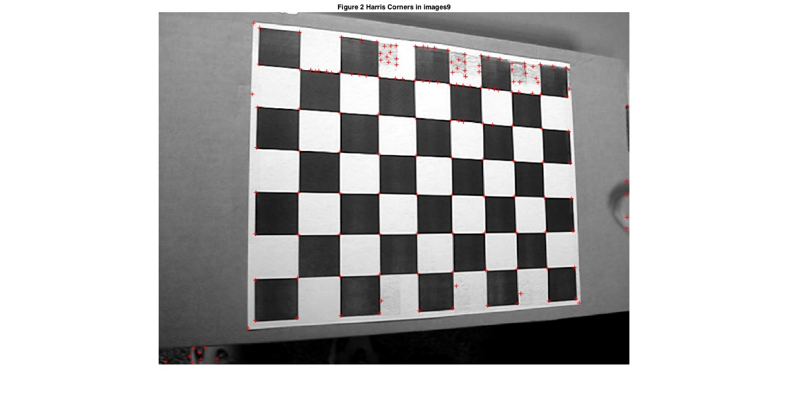

Figure 3. Grid Points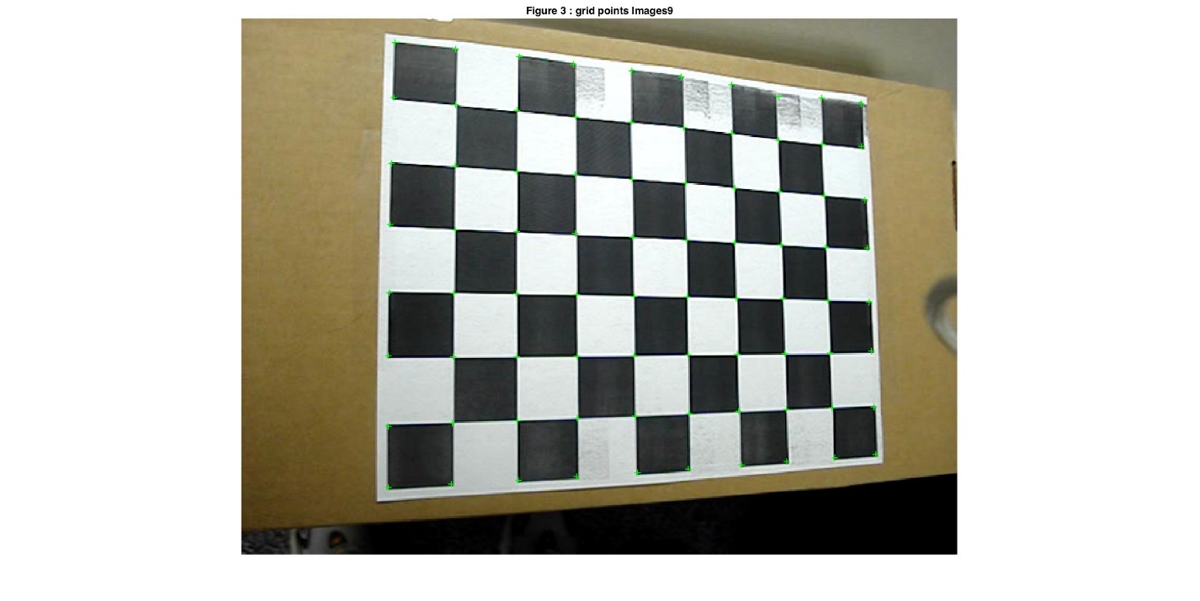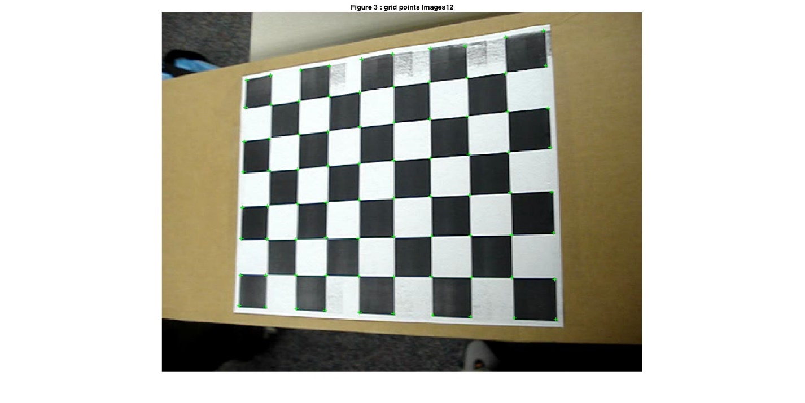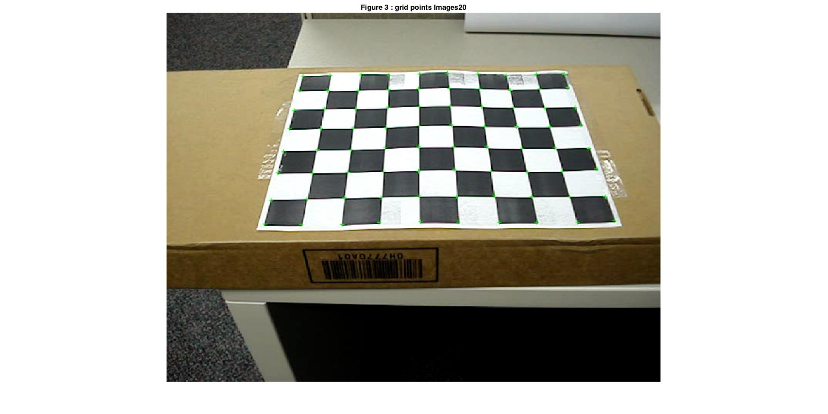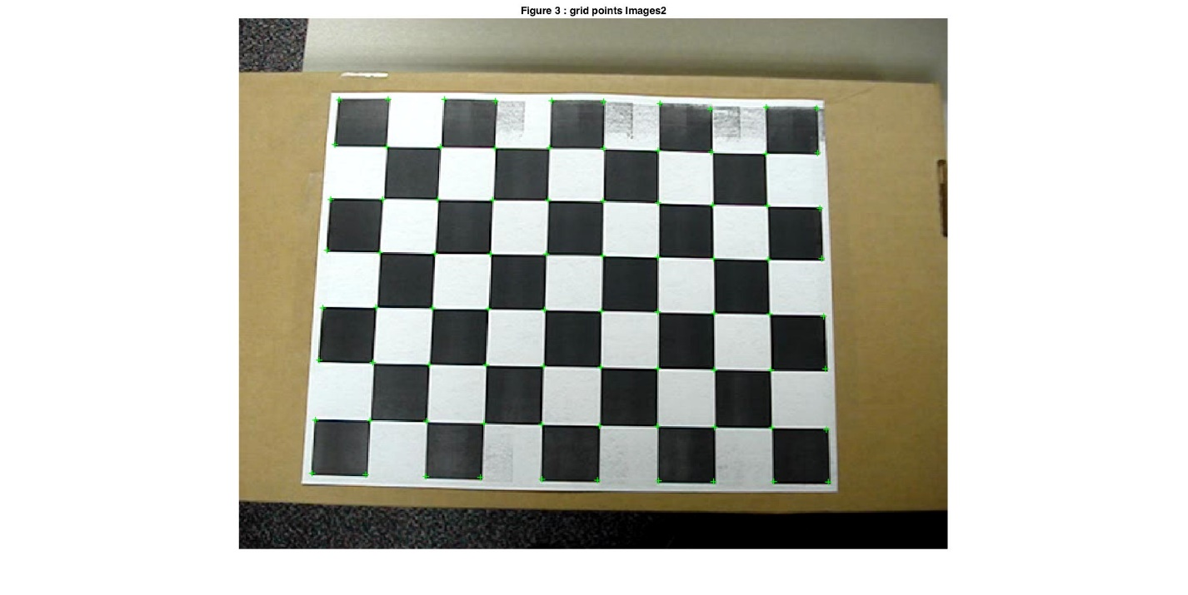

New Homography for images2

1.7456 0.1571 63.4936

0.0316 -1.6043 414.4186

0.0000 0.0004 1.0000

New Homography for images9

2.2440 0.0727 128.7522

0.3056 -1.9304 424.4314

0.0011 0.0003 1.0000

New Homography for images12

1.1277 0.0806 101.4547

-0.2833 -1.4293 394.5129

-0.0009 0.0003 1.0000

New Homography for images20

1.6909 0.5302 125.9504

-0.0143 -0.7965 277.1073

0.0000 0.0016 1.0000

Intrinsic Params

v0 =

232.3795

lambda =

-0.7610

alpha =

724.7748

beta =

710.9711

gamma =

-0.4152

u0 =

329.8133

Camera Calibration Matrix (K)

724.7748 -0.4152 329.8133

0 710.9711 232.3795

0 0 1.0000

Rotation matrix for image2

0.9998 0.0141 0.0044

0.0180 -0.9914 -0.1656

0.0014 0.1657 -0.9915

Translation vector for image2

-152.5734

106.3566

415.3861

New Rotation matrix for image2 after enforcing constraints

0.0767 -0.9609 -0.2660

0.4344 0.2724 -0.8586

0.8975 -0.0497 0.4383

New Rotation matrix * Rotation Matrix_transpose for image2 after enforcing constraints

1.0000 0.0000 -0.0000

0.0000 1.0000 -0.0000

-0.0000 -0.0000 1.0000

Rotation matrix for image9

0.9235 -0.0093 0.3832

0.0273 -0.9944 -0.0935

0.3827 0.0974 -0.9180

Translation vector for image9

-98.2890

95.7611

354.5050

New Rotation matrix for image9 after enforcing constraints

0.8771 0.4753 0.0692

-0.4604 0.8730 -0.1611

-0.1370 0.1095 0.9845

New Rotation matrix * Rotation Matrix_transpose for image9 after enforcing constraints

1.0000 0.0000 0.0000

0.0000 1.0000 0.0000

0.0000 0.0000 1.0000

Rotation matrix for image12

0.9137 -0.0079 -0.4044

-0.0556 -0.9868 -0.1164

-0.4025 0.1308 -0.9021

Translation vector for image12

-147.8943

107.0873

469.5882

New Rotation matrix for image12 after enforcing constraints

0.9297 -0.3670 0.0302

0.3679 0.9291 -0.0361

-0.0149 0.0447 0.9989

New Rotation matrix * Rotation Matrix_transpose for image12 after enforcing constraints

1.0000 -0.0000 -0.0000

-0.0000 1.0000 0.0000

-0.0000 0.0000 1.0000

Rotation matrix for image20

0.9999 -0.0055 -0.0044

-0.0097 -0.7101 -0.7013

0.0034 0.7013 -0.7102

Translation vector for image20

-120.7318

27.0065

429.2816

New Rotation matrix for image20 after enforcing constraints

0.7198 0.5302 0.4480

-0.6917 0.6016 0.3994

-0.0577 -0.5974 0.7998

New Rotation matrix * Rotation Matrix_transpose for image20 after enforcing constraints

1.0000 0.0000 -0.0000

0.0000 1.0000 -0.0000

-0.0000 -0.0000 1.0000

**Err_reprojection**

**Green circles : p_correct  
Blue circle: p_projection**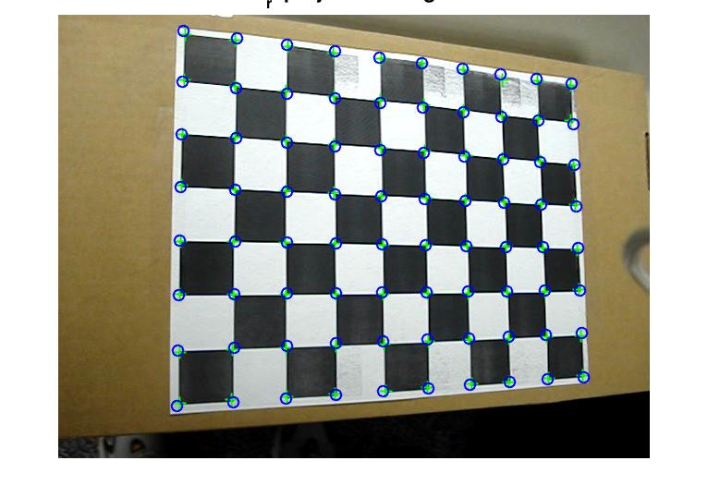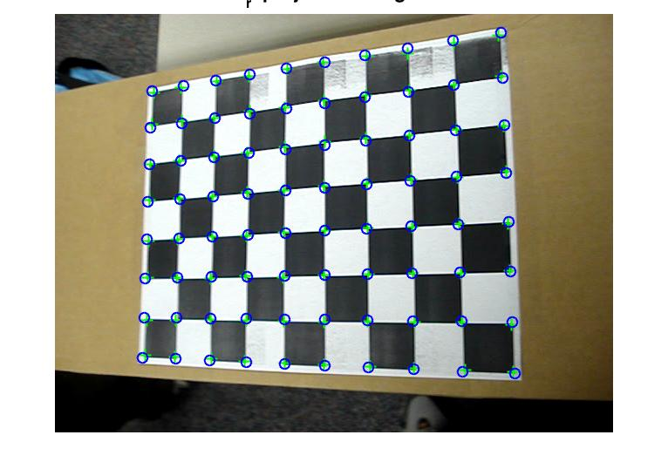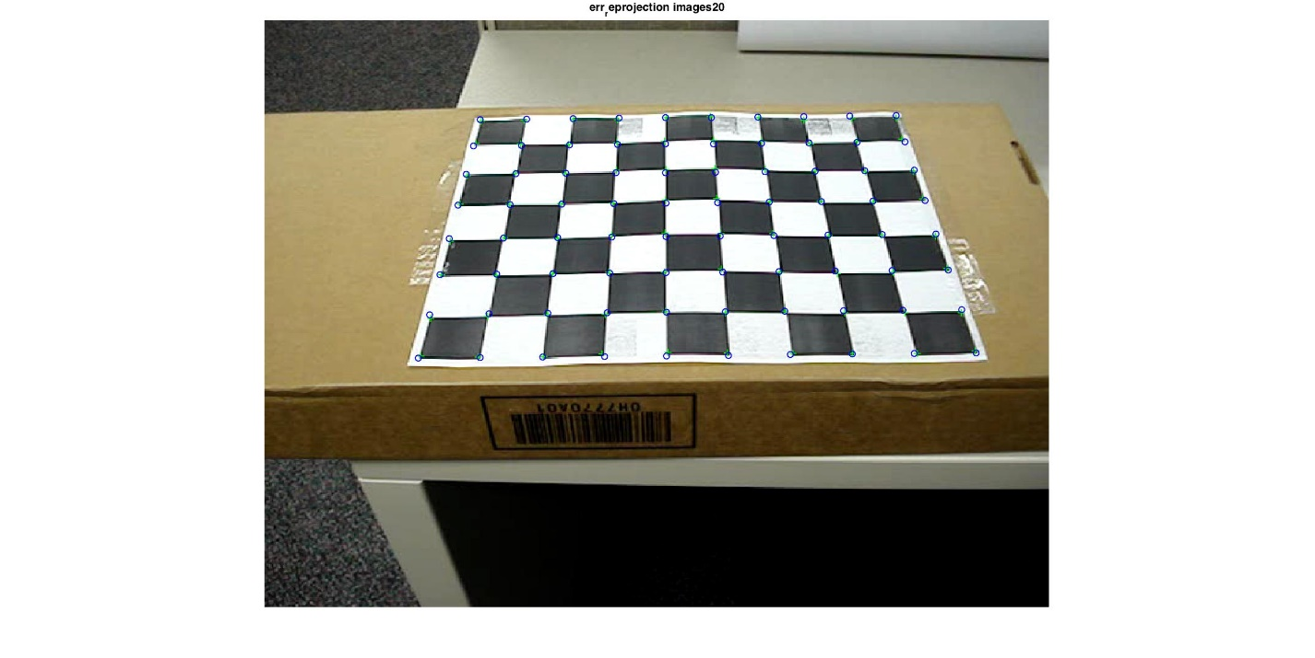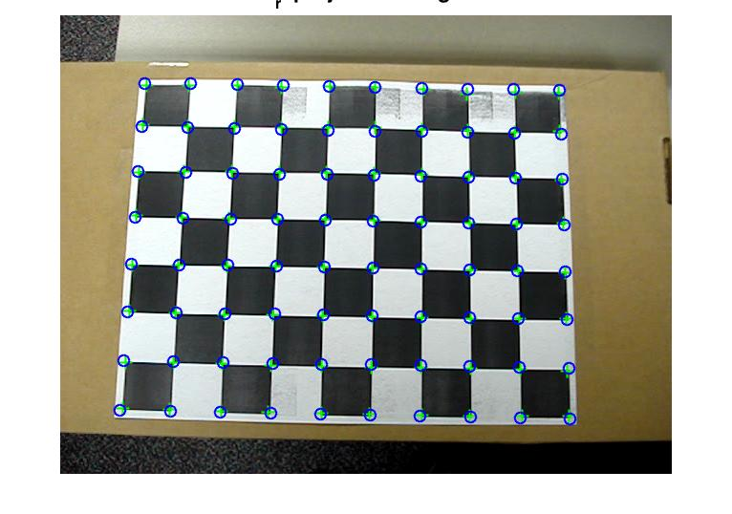

**Automatic gridboard corner selection**

To select corners without user manual input, we can specify number of blocks and also dimension of each block (30x30 mm2). This will calculate the world coordinates of corners automatically.

To calculate image coordinates of the corners, simply run the above designed subroutine for corner detection in 2 and run it with the automatically detected world coordinates for corners.

**Part 3 Augmented Reality**

Augmenting an Image : RUID 163005645, sum = 10.  
Clipart 0 unavailable. Using 4.png. Simply change line 1 of AugmentingReality.m to see for other clip arts.

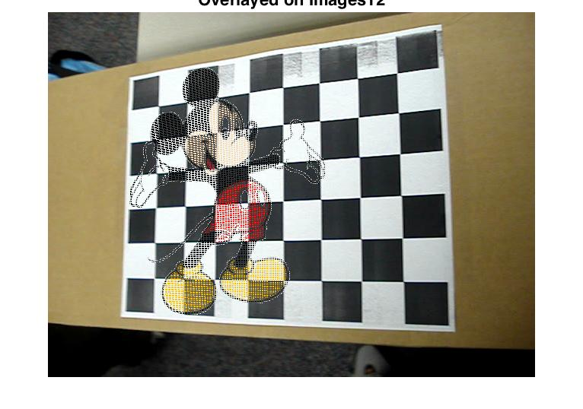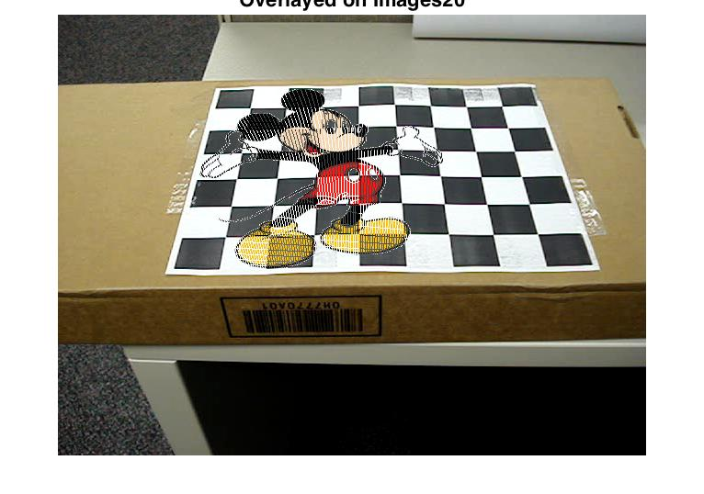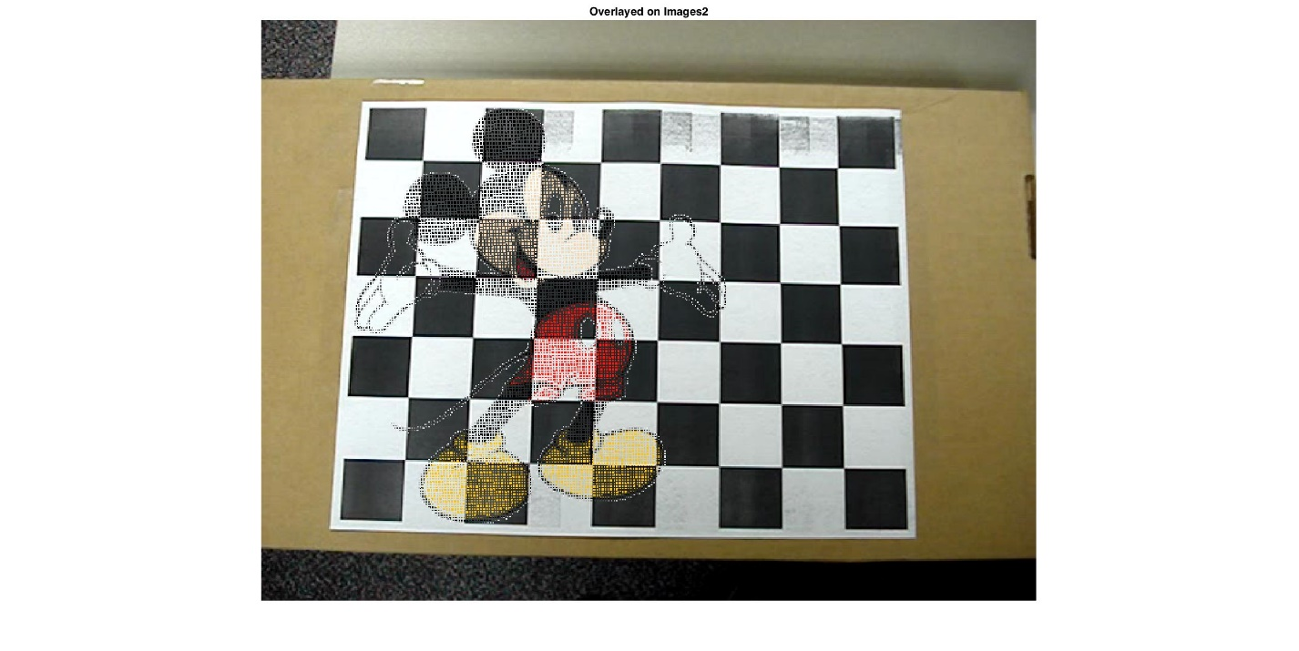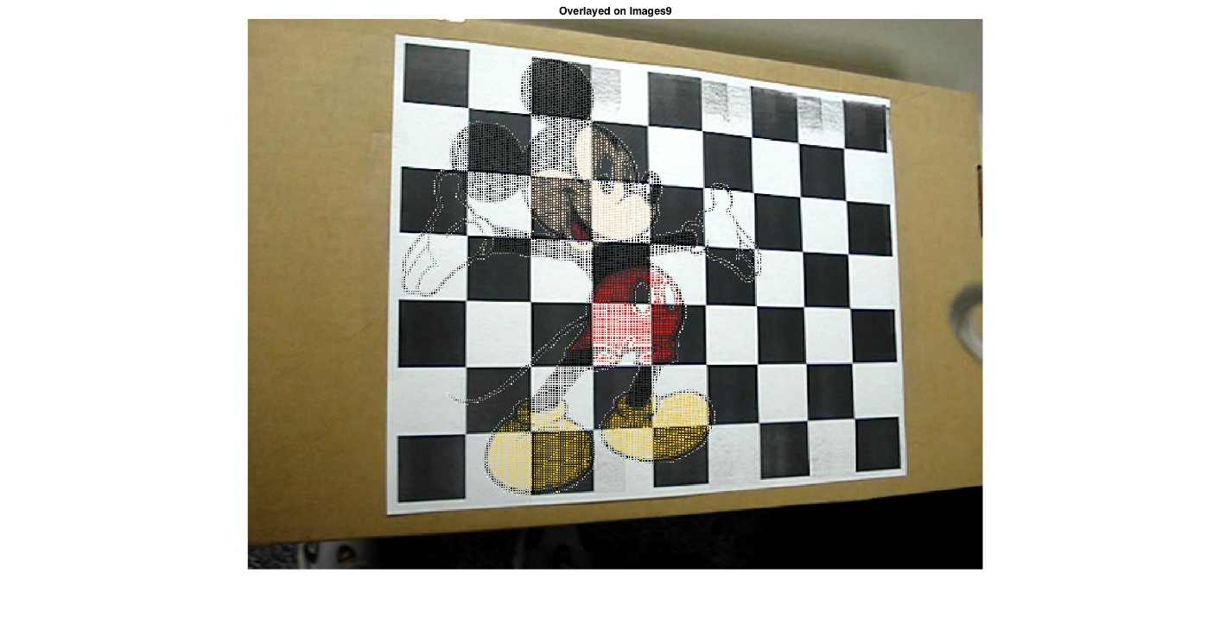

**Augmenting an Object**

3D coordinates of cube for images2.png

63.4936 414.4186 1.0000 -9.2855 432.7454 1.0000

63.4936 414.4186 1.0000 74.9434 260.6775 1.0000

63.4936 414.4186 1.0000 220.5330 417.1416 1.0000

-9.2855 432.7454 1.0000 191.6398 436.2219 1.0000

-9.2855 432.7454 1.0000 8.4184 237.1324 1.0000

74.9434 260.6775 1.0000 226.5392 263.3506 1.0000

74.9434 260.6775 1.0000 8.4184 237.1324 1.0000

220.5330 417.1416 1.0000 226.5392 263.3506 1.0000

220.5330 417.1416 1.0000 191.6398 436.2219 1.0000

200.5179 240.5279 1.0000 226.5392 263.3506 1.0000

200.5179 240.5279 1.0000 191.6398 436.2219 1.0000

200.5179 240.5279 1.0000 8.4184 237.1324 1.0000

3D coordinates of cube for images9.png

128.7522 424.4314 1.0000 157.8233 462.0283 1.0000

128.7522 424.4314 1.0000 132.0316 244.6499 1.0000

128.7522 424.4314 1.0000 301.4287 411.9168 1.0000

157.8233 462.0283 1.0000 374.9269 441.8066 1.0000

157.8233 462.0283 1.0000 161.1791 226.8194 1.0000

132.0316 244.6499 1.0000 300.6185 247.9800 1.0000

132.0316 244.6499 1.0000 161.1791 226.8194 1.0000

301.4287 411.9168 1.0000 300.6185 247.9800 1.0000

301.4287 411.9168 1.0000 374.9269 441.8066 1.0000

371.8442 233.0029 1.0000 300.6185 247.9800 1.0000

371.8442 233.0029 1.0000 374.9269 441.8066 1.0000

371.8442 233.0029 1.0000 161.1791 226.8194 1.0000

3D coordinates of cube for images12.png

101.1891 394.5842 1.0000 -13.9594 410.0611 1.0000

101.1891 394.5842 1.0000 105.9342 259.4823 1.0000

101.1891 394.5842 1.0000 219.7901 399.8262 1.0000

-13.9594 410.0611 1.0000 120.8141 418.1286 1.0000

-13.9594 410.0611 1.0000 -4.8685 246.4339 1.0000

105.9342 259.4823 1.0000 221.8222 253.6616 1.0000

105.9342 259.4823 1.0000 -4.8685 246.4339 1.0000

219.7901 399.8262 1.0000 221.8222 253.6616 1.0000

219.7901 399.8262 1.0000 120.8141 418.1286 1.0000

126.4851 237.9873 1.0000 221.8222 253.6616 1.0000

126.4851 237.9873 1.0000 120.8141 418.1286 1.0000

126.4851 237.9873 1.0000 -4.8685 246.4339 1.0000

3D coordinates of cube for images20.png

125.8054 277.1702 1.0000 87.9123 161.7263 1.0000

125.8054 277.1702 1.0000 151.6021 178.9976 1.0000

125.8054 277.1702 1.0000 277.7101 275.9937 1.0000

87.9123 161.7263 1.0000 267.0309 160.1565 1.0000

87.9123 161.7263 1.0000 123.3150 65.8767 1.0000

151.6021 178.9976 1.0000 283.7763 177.8599 1.0000

151.6021 178.9976 1.0000 123.3150 65.8767 1.0000

277.7101 275.9937 1.0000 283.7763 177.8599 1.0000

277.7101 275.9937 1.0000 267.0309 160.1565 1.0000

275.6241 64.4138 1.0000 283.7763 177.8599 1.0000

275.6241 64.4138 1.0000 267.0309 160.1565 1.0000

275.6241 64.4138 1.0000 123.3150 65.8767 1.0000

Cube to Augment

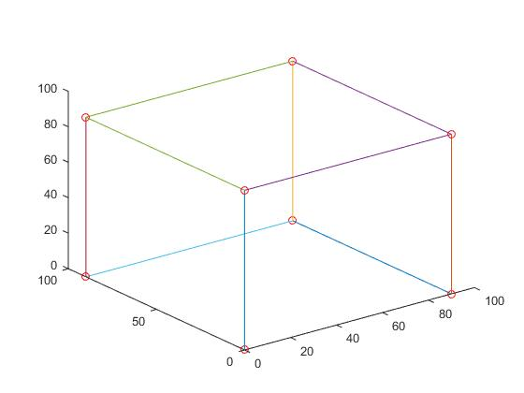

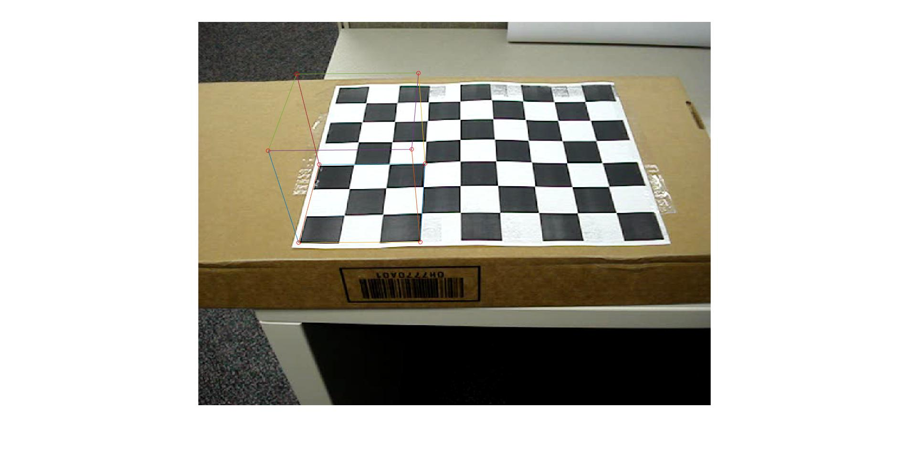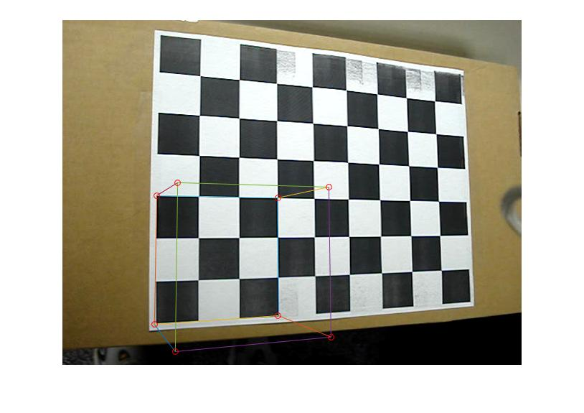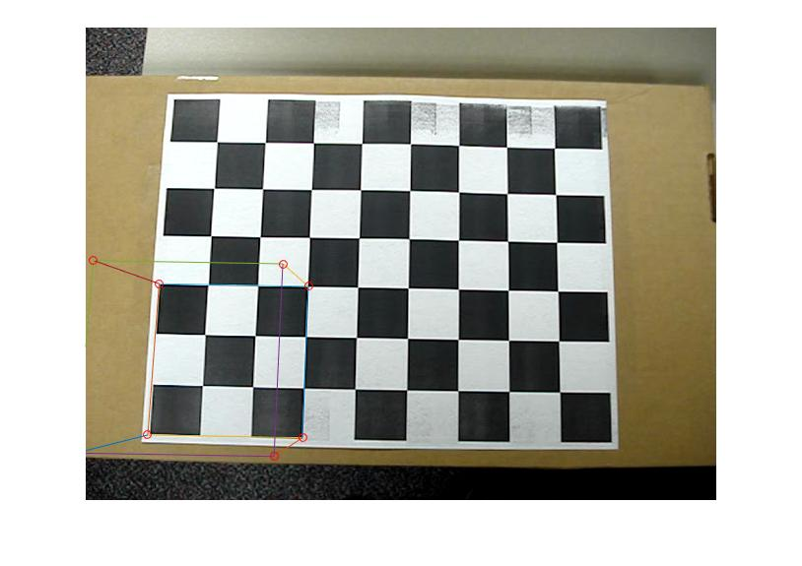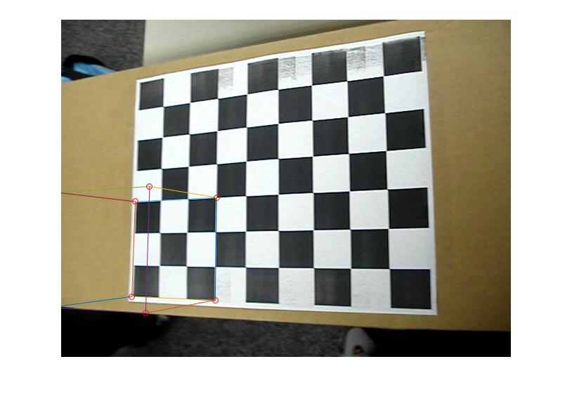

**Extra Credit**